## 5. Create New Activity in Android Studio

**From One Activity to another Activity and back to First Activity**

**Android File: PushYou**

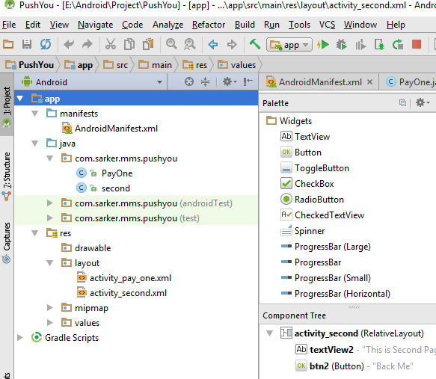

1. **AndroidManifest.xml**

*<?***xml version="1.0" encoding="utf-8"***?>*<**manifest xmlns:android="http://schemas.android.com/apk/res/android"  
package="com.sarker.mms.pushyou"**>  
  
<**application  
android:allowBackup="true"  
android:icon="@mipmap/ic_launcher"  
android:label="@string/app_name"  
android:supportsRtl="true"  
android:theme="@style/AppTheme"**>  
<**activityandroid:name=".PayOne"**>  
<**intent-filter**>  
<**action android:name="android.intent.action.MAIN"** />  
  
<**category android:name="android.intent.category.LAUNCHER"** />  
</**intent-filter**>  
</**activity**>  
<**activityandroid:name=".second"**></**activity**>  
</**application**>  
  
</**manifest**>

1. **PayOne.java**

**package** com.sarker.mms.pushyou;  
  
**import** android.content.Intent;  
**import** android.support.v7.app.AppCompatActivity;  
**import** android.os.Bundle;  
**import** android.view.View;  
**import** android.widget.Button;  
  
  
**public class** PayOne **extends** AppCompatActivity {  
  
**public** Button **btn1**;  
**public void** init(){  
**btn1**=(Button)findViewById(R.id.***btn1***);  
**btn1**.setOnClickListener(**new** View.OnClickListener() {  
@Override  
**public void** onClick(View v) {  
 Intent toy = **new**Intent(PayOne.**this**, second.**class**);  
startActivity(toy);  
 }  
 });  
 }  
  
@Override  
**protected void** onCreate(Bundle savedInstanceState) {  
**super**.onCreate(savedInstanceState);  
setContentView(R.layout.***activity_pay_one***);  
init();  
 }  
}

1. **second.java**

**package** com.sarker.mms.pushyou;  
  
**import** android.content.Intent;  
**import** android.support.v7.app.AppCompatActivity;  
**import** android.os.Bundle;  
**import** android.view.View;  
**import** android.widget.Button;  
  
**public class** second **extends** AppCompatActivity {  
  
**public** Button **btn2**;  
**public void** init(){  
*//btn2=(Button)findViewById(R.id.btn2);***btn2**=(Button)findViewById(R.id.***btn2***);  
**btn2**.setOnClickListener(**new** View.OnClickListener() {  
@Override  
**public void** onClick(View v) {  
 Intent toy = **new**Intent(second.**this**, PayOne.**class**);  
startActivity(toy);  
 }  
 });  
 }  
  
@Override  
**protected void** onCreate(Bundle savedInstanceState) {  
**super**.onCreate(savedInstanceState);  
setContentView(R.layout.***activity_second***);  
init();  
  
 }  
}

1. **activity_pay_one.xml**

*<?***xml version="1.0" encoding="utf-8"***?>*<**RelativeLayoutxmlns:android="http://schemas.android.com/apk/res/android"  
xmlns:tools="http://schemas.android.com/tools"  
android:id="@+id/activity_pay_one"  
android:layout_width="match_parent"  
android:layout_height="match_parent"  
android:paddingBottom="@dimen/activity_vertical_margin"  
android:paddingLeft="@dimen/activity_horizontal_margin"  
android:paddingRight="@dimen/activity_horizontal_margin"  
android:paddingTop="@dimen/activity_vertical_margin"  
tools:context="com.sarker.mms.pushyou.PayOne"**>

<**TextView  
android:layout_width="wrap_content"  
android:layout_height="wrap_content"  
android:text="This is First Page"  
android:textSize="38sp"**/>  
  
<**Button  
android:text="Click Me"  
android:layout_width="wrap_content"  
android:textSize="20sp"  
android:layout_height="wrap_content"  
android:layout_below="@+id/textView"  
android:layout_alignParentLeft="true"  
android:layout_alignParentStart="true"  
android:layout_marginLeft="96dp"  
android:layout_marginStart="96dp"  
android:layout_marginTop="109dp"  
  
android:id="@+id/btn1"  
android:layout_alignRight="@+id/textView"  
android:layout_alignEnd="@+id/textView"** />  
</**RelativeLayout**>

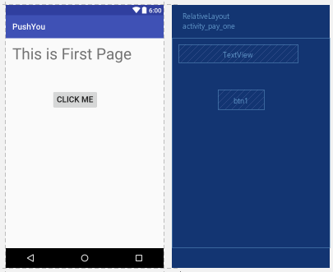

1. **activity_second.xml**

*<?***xml version="1.0" encoding="utf-8"***?>*<**RelativeLayoutxmlns:android="http://schemas.android.com/apk/res/android"  
xmlns:tools="http://schemas.android.com/tools"  
android:id="@+id/activity_second"  
android:layout_width="match_parent"  
android:layout_height="match_parent"  
android:paddingBottom="@dimen/activity_vertical_margin"  
android:paddingLeft="@dimen/activity_horizontal_margin"  
android:paddingRight="@dimen/activity_horizontal_margin"  
  
android:paddingTop="@dimen/activity_vertical_margin"  
tools:context="com.sarker.mms.pushyou.second"**>  
  
<**TextView  
android:text="This is Second Page"  
android:textSize="35sp"  
android:layout_width="wrap_content"  
android:layout_height="wrap_content"  
android:layout_alignParentTop="true"  
android:layout_centerHorizontal="true"  
android:layout_marginTop="42dp"  
android:id="@+id/textView2"** />  
  
<**Button  
android:text="Back Me"  
android:layout_width="1000dp"  
android:layout_height="wrap_content"  
android:textSize="28sp"  
android:layout_marginTop="89dp"  
android:id="@+id/btn2"  
android:layout_below="@+id/textView2"  
android:layout_alignParentLeft="true"  
android:layout_alignParentStart="true"** />  
</**RelativeLayout**>

